Name: .............................................

Class: .............................................

Control and regulation: Class test

**Instructions to students**

Please answer all questions in the spaces provided. There is to be no talking during the test.

**Marks**

Total marks: 45 marks

Section I - Multiple choice questions: 10 marks

Section II - Short answer questions: 25 marks

Section III - Extended response questions: 10 marks

Section I: Multiple choice questions



1. Movement, balance and coordination are controlled by the:

* medulla.
* hypothalamus.
* cerebrum.
* cerebellum.

[1 mark]

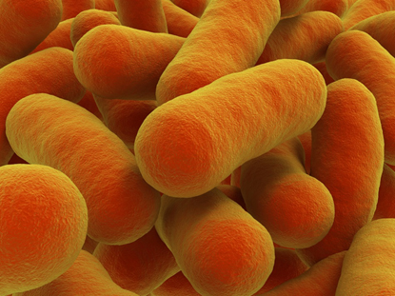

1. A pathogen is:

* a unicellular organism with a cell wall but no nucleus.
* a lifestyle choice that causes a disease such as a heart attack.
* something that contains genetic material surrounded by a protein coat, but is not considered living.
* a substance or organism that is capable of causing disease.

[1 mark]



1. The body’s second line of defence against infection involves:

* mucous membranes.
* the digestive system.
* the endocrine system.
* the immune system.

[1 mark]

1. The immunity gained from a mother’s placenta or breast milk is known as:

* natural passive immunity.
* natural active immunity.
* acquired passive immunity.
* acquired active immunity.

[1 mark]

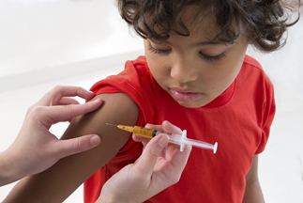

1. Which one of the following would *not* be used as a vaccine?

* the dead microbe.
* an alive but weakened form of the microbe.
* broken-up parts of the microbe.
* a healthy full-strength form of the microbe.

[1 mark]

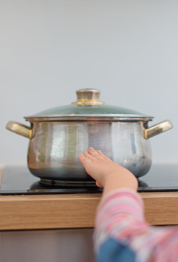

1. You touch something very hot and burn your hand. The part of the nervous system that immediately sends the message to your muscles so that you move your hand is:

* the spinal cord.
* the cerebrum.
* the brain.
* an effector.

[1 mark]

1. The nervous system does *not*:

* react to changes inside and outside the body.
* help all parts of the body communicate with each other.
* transfer information using both electrical and chemical means.
* transport nutrients around the body.

[1 mark]

1. Which of the following lists organs that do *not* secrete hormones?

* eye, placenta, salivary glands
* parathyroid gland, adrenal gland, testes
* pituitary gland, thyroid gland, pancreas
* ovaries, hypothalamus, thyroid gland

[1 mark]

The parathyroid gland continuously monitors the amount of calcium in the blood. If the calcium levels go down a little bit, the parathyroid glands respond to this and produce parathyroid hormone (PTH), which targets the bones and takes some calcium out so that calcium enters the blood. When the calcium in the blood is high enough, the parathyroid glands stop producing PTH.

1. Turning off the hormone production by the parathyroid gland is an example of:

* neutral feedback.
* positive feedback.
* random response.
* negative feedback.

[1 mark]

1. The part of the nervous system that is responsible for body processes such as breathing, sweating and digestion is:

* the autonomic system.
* the central nervous system.
* the neurotransmitter system.
* the parasympathetic system.

[1 mark]

Section II: Short answer questions

• The basic unit of the nervous system is the nerve.

• The endocrine system is typically faster to respond than the nervous system.

• The autonomic nervous system is responsible for conscious skeletal movement.

1. All three statements are incorrect. Rewrite each statement to make it true.

[3 marks]

1. In 1848 a railroad worker named Phineas Gage had a metal rod blasted through his brain during an explosion. He survived but his personality and his behaviour reportedly changed dramatically after the accident. Suggest a reason for the change in his behaviour and personality.

[2 marks]

1. Compare and contrast the nervous system and the endocrine system by completing the following table:

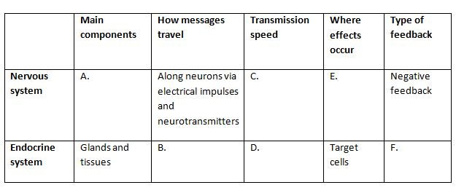

[6 marks]

1. Explain the difference between an infectious disease and a non-infectious disease.

[2 marks]

1. Identify two features of the skin that make it a good first barrier to infection.

[2 marks]

1. Your body detects changes in the environment and within itself using specialised structures to detect specific types of changes. Identify the proper terms for these changes and the structures that detect them.

[2 marks]

1. Define the term ‘homeostasis’ and briefly describe how the body achieves it.

[4 marks]

1. Identify where in the body the hormone erythropoietin is produced. Describe its function and how the artificial use of erythropoietin can improve sporting ability as well as be a health risk.

[4 marks]

Section III: Extended response questions

1. Explain the differences between the specific and non-specific immune response. Provide two examples of typical actions for each type of immune response.

[6 marks]

1. Multiple sclerosis is an autoimmune disease. Describe the symptoms of multiple sclerosis and identify whether it is an infectious or non-infectious disease.

[4 marks]